**DATA VISUALIZATION AND EXPLORATION WITH R LAB**

**TASK- 6**

**TASK**

**DATA VISUALIZATION USING PLOT FUNCTION IN R**

**Plot all the Data Visualizations on the dataset. Apply all the possible arguments and make the visualization looks attractive.**

**Apply axes, colours, points, lines, legend. text, titles,main titles, subtitles, labels etc.**

**a.** Histogram

**b.** Barplot

**c.** Boxplot

**d.** Line graph

**e.** Density plot

**f.** Scatterplot

**g.** Pie chart

**h.** Mosaic plot

**i.** Correlation Matrix

**LOADING DATASET:**

library(readxl)

pd <- read_excel("C:/Users/ramri/Downloads/tech_layoffs.xlsx")

**OUTPUT OF DATASET:**

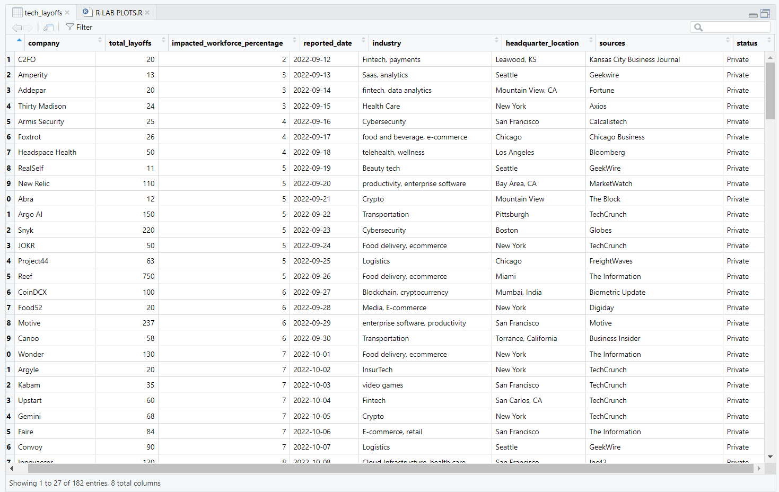

**a. Plot Histogram and visualize with the help of a dataset in R?**

**Aim:**

To Plot Histogram and visualize with the help of a dataset in R and applying axes, colours, points, lines, legend, text, titles, main titles, subtitles, labels etc.

**Code:**

#HISTOGRAM

hist(pd$total_layoffs, main = "HISTOGRAM LAYOFFS ANALYSIS",

sub = "Source : Tech Company Layoffs in 2023- Google",

xlab = "LAYOFF COUNT",

ylab = "FREQUENCY",

col = "darkblue",

border = "white",

breaks = 35,

xlim = c(0, 1000),

ylim = c(0, 100),

las = 1)

abline(v = median(pd$total_layoffs), col = "red", lwd = 2)

text(median(pd$total_layoffs), 90, "Median", col = "red", pos = 4)

legend("topright", legend = c("2022", "2023"),

title = "YEAR",

fill = c("blue", "red"), bg = "white")

**Output:**

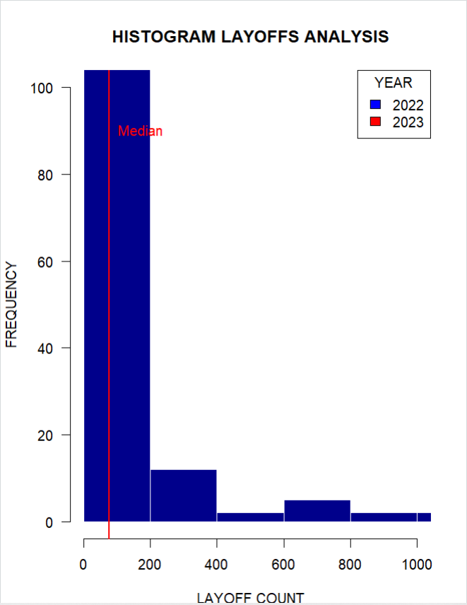

**b. Plot Bar Chart and visualize with the help of a dataset in R?**

**Aim:**

To Plot Bar Chart and visualize with the help of a dataset in R and applying axes, colours, points, lines, legend, text, titles, main titles, subtitles, labels etc.

**Code:**

#BARPLOT

library(dplyr)

lc <- pd %>%

group_by(company) %>%

summarize(total_layoffs = sum(as.numeric(as.character(total_layoffs)), na.rm = TRUE))

lc <- lc[order(-lc$total_layoffs),]

top_10_layoffs <- head(lc, 10)

print(top_10_layoffs)

barplot(table(top_10_layoffs$company),

as.numeric(top_10_layoffs$total_layoffs),

names.arg = top_10_layoffs$company,

col = "lightblue",

border = "black",

xlab = "Company",

ylab = "Layoffs",

ylim = c(0, 2),

main = "TECH LAYOFFS",

sub = "Souce : Forbes Tech Layoffs Analysis ")

legend("topright",

legend = "Layoffs",

fill = "lightblue",

border = "black",

bty = "n")

**Output:**

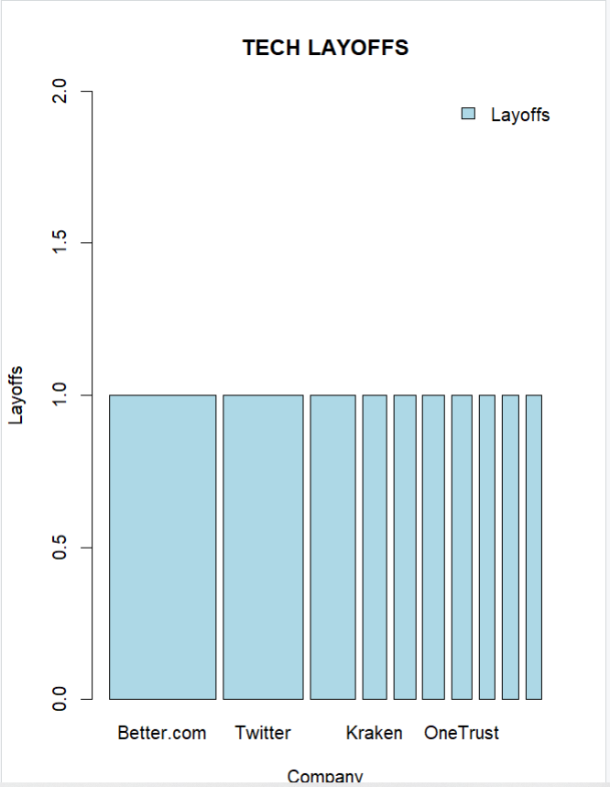

**c. Plot Boxplot and visualize with the help of a dataset in R?**

**Aim:**

To Plot Boxplot and visualize with the help of a dataset in R and applying axes, colours, points, lines, legend, text, titles, main titles, subtitles, labels etc.

**Code:**

#boxplot

boxplot(pd$total_layoffs,

xlab = "Companies",

ylab = "Number of Layoffs",

col = "lightblue",

border = "black",

horizontal = TRUE,

notch = TRUE,

notchwidth = 0.5,

medcol = "red",

whisklty = 2,

staplelty = 1,

outcol = "blue",

outpch = 19,

ylim = c(0, 300))

legend("topright",

legend = c("Data"),

pch = 19,

col = "blue")

text(150, 0, "Source: Forbes Research", pos = 1)

abline(h = seq(0, 350, by = 50), col = "gray", lty = 2)

abline(v = seq(0, 300, by = 100), col = "gray", lty = 2)

title(main = "Boxplot of Tech Layoffs",

col.main = "red")

**Output:**

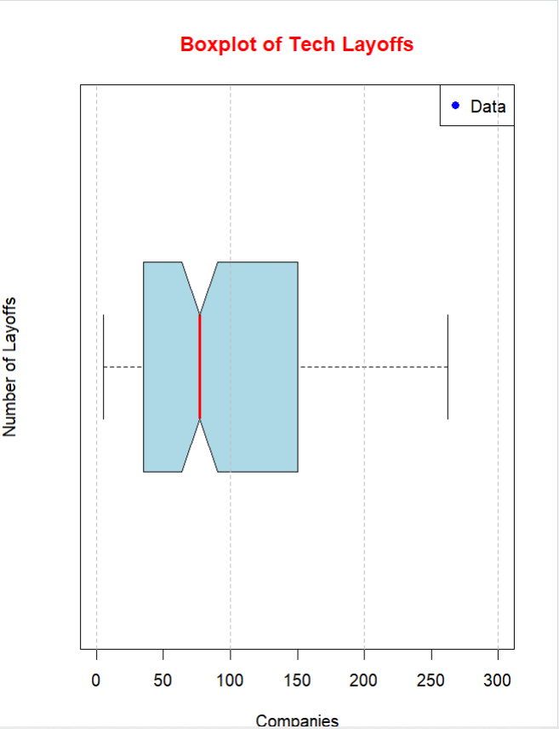

**d. Plot Line Graph and visualize with the help of a dataset in R?**

**Aim:**

To Plot Line Graph and visualize with the help of a dataset in R and applying axes, colours, points, lines, legend, text, titles, main titles, subtitles, labels etc.

**Code:**

#LINE GRAPH

plot(pd$total_layoffs,

type = "o",

lwd = 2,

pch = 19,

col = "blue",

xlab = "Time",

ylab = "Number of Layoffs",

xlim = c(1, 12),

ylim = c(0, 400),

main = "Tech Layoffs in 2022",

sub = "Sample Data",

cex.main = 1.2,

cex.lab = 1.2,

cex.sub = 1,

col.main = "red")

legend("topright",

legend = c("Data"),

pch = 19,

col = "blue")

text(11, 350, "Source: Forbes Research", pos = 4)

abline(h = seq(0, 400, by = 50), col = "gray", lty = 2)

abline(v = seq(1, 12), col = "gray", lty = 2)

**Output:**

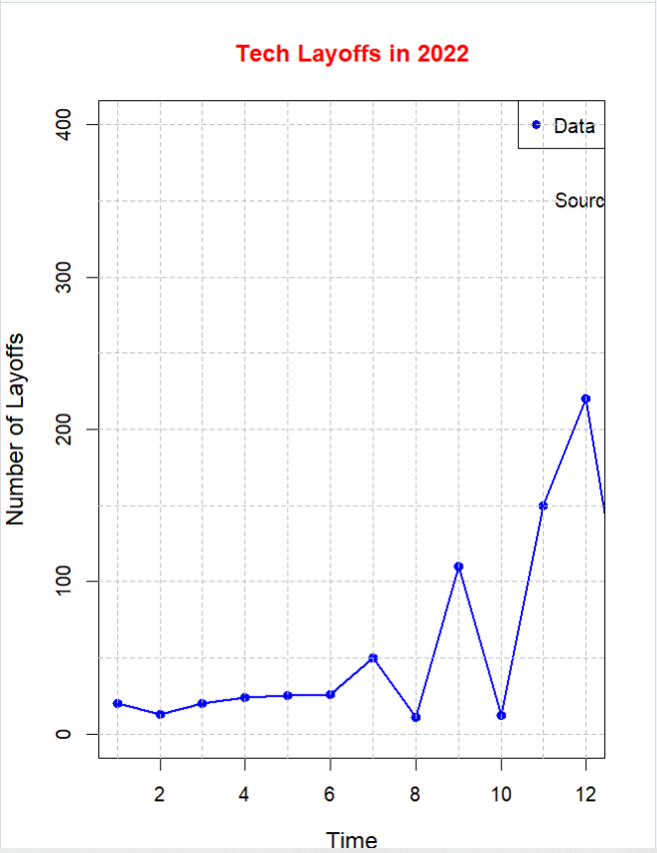

**e. Plot Density Plot and visualize with the help of a dataset in R?**

**Aim:**

To Plot Density Plot and visualize with the help of a dataset in R and applying axes, colours, points, lines, legend, text, titles, main titles, subtitles, labels etc.

**Code:**

# Density Plot

plot(density(pd$total_layoffs),

main = "Density Plot of Tech Layoffs in 2022",

xlab = "Number of Layoffs",

ylab = "Density",

col = "blue",

lwd = 2,

ylim = c(0, 0.015))

legend("topright",

legend = "Tech Layoffs",

lwd = 2,

col = "blue")

text(200, 0.014, "Source: Forbes Research", pos = 4)

abline(h = seq(0, 0.015, by = 0.001), col = "gray", lty = 2)

abline(v = seq(0, 400, by = 50), col = "gray", lty = 2)

**Output:**

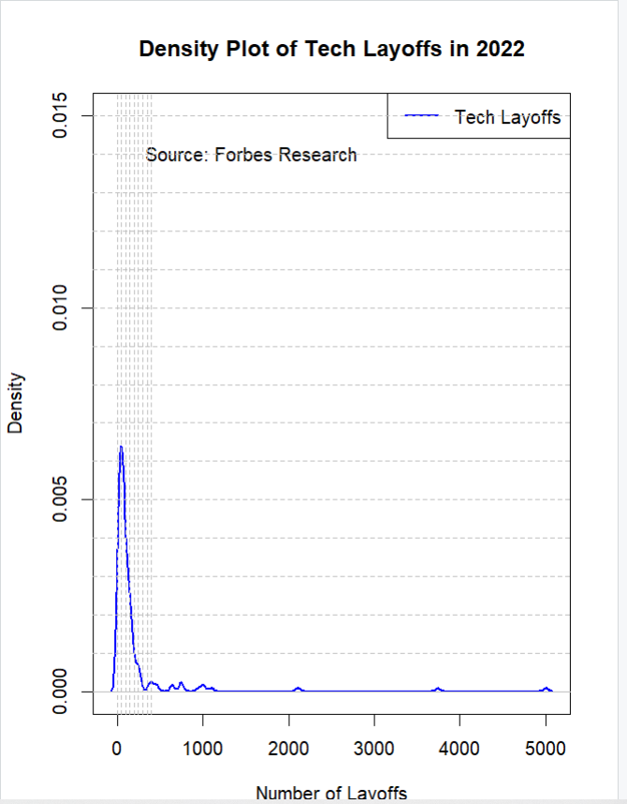

**f. Plot Scatter Plot and visualize with the help of a dataset in R?**

**Aim:**

To Plot Scatter Plot and visualize with the help of a dataset in R and applying axes, colours, points, lines, legend, text, titles, main titles, subtitles, labels etc.

**Code:**

# Scatter Plot

plot(pd$impacted_workforce_percentage, pd$total_layoffs,

main = "Tech Layoffs in 2022",

xlab = "Quarter",

ylab = "Number of Layoffs",

col = "blue",

pch = 16,

ylim = c(0, 400),

xlim = c(0, 5),

bty = "L")

abline(lm(pd$total_layoffs ~ pd$impacted_workforce_percentage), col = "red", lwd = 2)

legend("topright",

legend = "Tech Layoffs",

col = "blue",

pch = 16)

text(4.5, 350, "Source: Forbes Research", pos = 4)

**Output:**

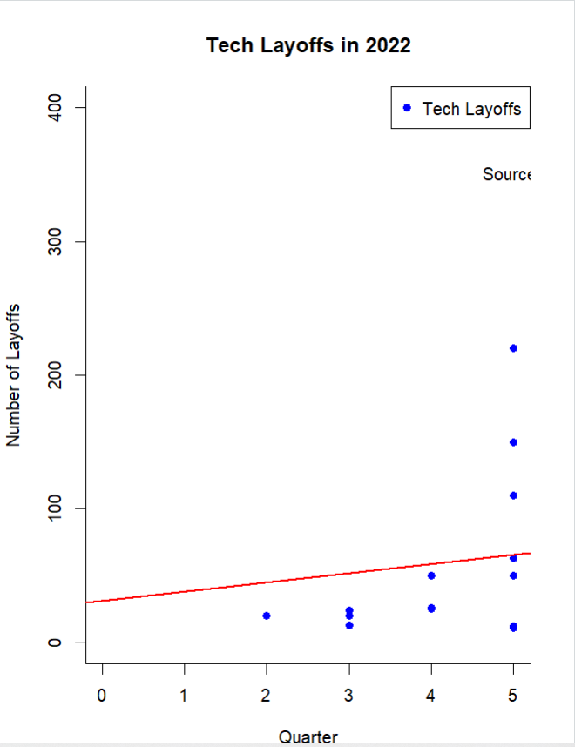

**g. Plot Pie Chart and visualize with the help of a dataset in R?**

**Aim:**

To Plot Pie Chart and visualize with the help of a dataset in R and applying axes, colours, points, lines, legend, text, titles, main titles, subtitles, labels etc.

**Code:**

cyl_table <- table(pd$cyl)

pie(cyl_table,

main="Pie Chart of Cyclic cities",

col=rainbow(length(cyl_table)),

labels=c("Total Layoff", "Impacted Workforce", "Status"))

legend("topright",legend = c("Total Layoff", "Impacted Workforce", "Status"),

col = c("green","yellow","blue"),

pch = 16,

bty = "n")

**Output:**

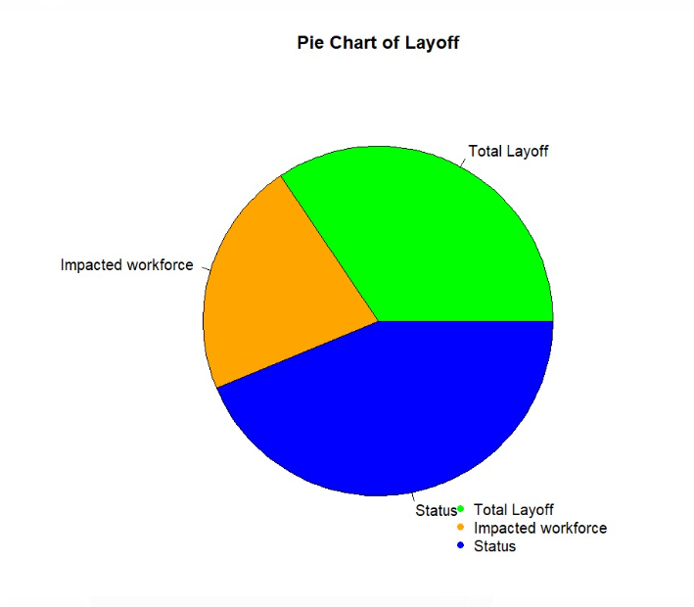

**h. Plot Mosaic Plot and visualize with the help of a dataset in R?**

**Aim:**

To Plot Mosaic Plot and visualize with the help of a dataset in R and applying axes, colours, points, lines, legend, text, titles, main titles, subtitles, labels etc.

**Code:**

#mosaic plot

library(vcd)

df <- data.frame(

Company = c("Tech", "Non- Tech", "Tech", "Non- Tech", "Tech", "Non- Tech"),

Layoff_status = c("More", "Less", "Less", "More", "None", "None"),

count = c(50, 60, 20, 30, 10, 5)

)

mosaicplot(count ~ Layoff_status + Company, data = df,

color = c("blue", "red", "green"),

las = 1,

main = "Mosaic Plot of Company and Layoff Status",

xlab = "Layoff Status",

ylab = "Company",

cex.axis = 0.8,

cex.lab = 0.8,

cex.main = 1.2,

font.main = 2,

grid = TRUE)

legend("topright",

legend = c("More", "Less", "None"),

fill = c("blue", "red", "green"))

text(5, 250, "Source: Forbes Research", pos = 4, cex = 0.8)

**Output:**

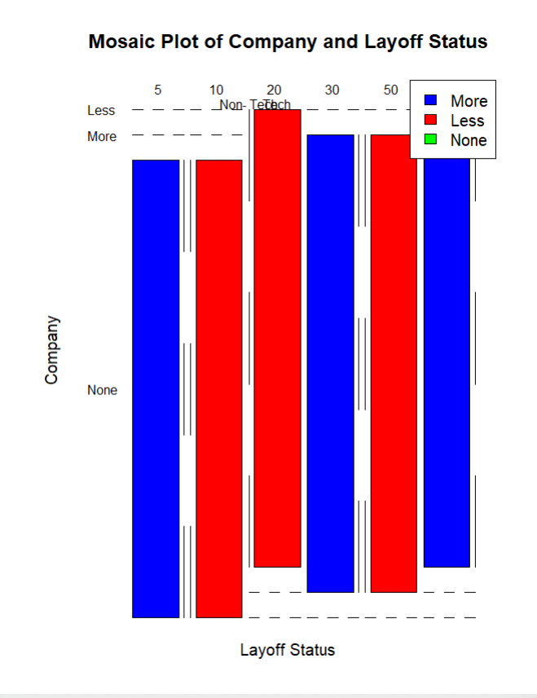

**i. Plot Correlation Plot and visualize with the help of a dataset in R?**

**Aim:**

To Plot Correlation Plot and visualize with the help of a dataset in R and applying axes, colours, points, lines, legend, text, titles, main titles, subtitles, labels etc.

**Code:**

#CORRELATION PLOT

library(fivethirtyeight)

library(corrplot)

data("airline_safety")

corr_matrix <- cor(mtcars)

corrplot(corr_matrix, method = "color", type = "upper", order = "hclust",

tl.col = "black", tl.srt = 45, tl.cex = 0.8,

addCoef.col = "black", addCoefasPercent = TRUE,

col = colorRampPalette(c("#FFFFFF", "#0092C3", "#D7191C"))(50))

**Output:**

